

ShipEx: last-mile delivery

An Analysis of Drone-Delivery Policies



April 10, 2023

Taya Kronrod, joseph colman, sharanya vutla, yazEED MASRI

OIM 411 Team 1

# Table of Contents

Introduction and Objective …………………………………………………………………………………. 2

Approach …………………………………………………………………………………………………………… 2

Policy ………………………………………………………………………………………………………………… 3

Findings …………………………………………………………………………………………………………….. 4

Scaled Findings ………………………………………………………………………………………………….. 5

Final Recommendations ……………………………………………………………………………………... 6

Conclusion …………………………………………………………………………………………………………. 7

Appendices ………………………………………………………………………………………………………… 9

# Introduction and Objective

ShipEx is a last-mile parcel carrier based in western MA that delivers packages directly to the end user’s home. Currently, ShipEx uses trucks to make its deliveries to its customers, but is heavily considering switching to a drone-delivery system in combination with the current truck-delivery system. A drone-delivery system could potentially decrease the time, money, environmental impact, and costs of ShipEx’s delivery route – at the same time, drones are a relatively new technology that has never been used for last-mile deliveries, hence the positives of using a drone system must be balanced against the effort it takes to implement and maintain it.

The objective of this report is to compare a truck-only delivery route with a truck-and-drone delivery route to calculate the monetary and timely advantages of either system. Data collected about customer demand and location over the course of five days was used to analyze both these routes as well as find the total route mileage, time spent driving or flying the drone, and total service time at each customer’s home. The following sections explain the approach used to find each optimal route, the policy used for drone implementation, and the calculations used to find high-level savings for comparison.

# Approach

The initial step to this analysis was to map out customer demand and find any trends. The collected Excel data was run through Tableau and projected two customer clusters around the depot (*see Appendix A)*, with demand changing very little throughout the five days. Knowing that ShipEx uses two trucks and two drones, it is logical to use one truck and one drone for each cluster of customers per day. To simplify the problem, we chose to look at the Day 1 demand sample (as it is the highest demand out of all the days) for each of the two clusters and map out optimal delivery routes with and without drone technology.

It is important to note that the baseline for our comparisons between truck and truck-and-drone delivery routes came from a Python algorithm that we set up to intake all customers for that day and output an optimal delivery path depending on mileage and total time. For the truck-only paths, we input all the customers for that day. For the truck-and-drone paths, we input only the customers who would be delivered to by truck based on the policies that we enacted (spoken about in the next section). The algorithm was able to do this for each individual day of demand and was extremely useful in finding a foundation to base our comparisons on. Future sections will show in detail the output of the algorithm and how we structured our routes.

# Policy

To input the drone technology, we first had to create a policy that states which customers drones can deliver to. To do this we had to examine the size of the package, the value of the package, and the type of home the package was to be delivered to.

It is evident that the size of the package matters a lot – drones are quite small and will likely not be able to deliver large, heavy packages. When looking at the demand data, we saw that about 2/3 of all packages were of small volume, with the rest being of medium volume and one package of large volume. Therefore, we decided that it would be most realistic and efficient for drones to carry small packages, as they are the majority of orders and align with a drone’s size.

Next, when looking at value, we had to consider that the value of packages is almost as important as the size. If a package is small but very valuable – like jewelry, a rare collectible, keys, a personal check, etc. – then delivery by drone may not be the safest choice. To define which value is drone-eligible, we took the average value of all packages over all 5 days and found it to be $108. We then decided that a drone may not take a small package that is worth over $108.

Lastly, the types of houses matter when discussing drone deliveries. Houses vary between single-family homes and condos, with a majority being single-family homes. Consideration was given to the difficulty of successfully delivering a package to a condo-style home – it will likely be much more difficult to deliver accurately and safely in a more crowded space. Therefore, we decided that drones would only be sent out to single-family homes.

Given all of these considerations and risk factors, we decided to test a policy where drones would be implemented to deliver small, under $108-value packages to single-family homes located off the truck’s path to decrease the truck’s driving time and mileage.

# Findings

Focusing on both customer clusters in Day 1, we were able to find efficiency differences in measures of time, distance, the cost of gas, the cost of labor, and more. First, we will focus on Cluster 1, for which the truck-only path and the truck-and-drone path can be seen in Appendix B. The total distance for the truck-only path was 12.13 miles, taking a total time of 125.69 minutes to complete. On the other hand, the truck-and-drone path totaled 9.59 miles and took 60.98 minutes to complete. The drone implementation decreased total distance by about 2.5 miles and cut the time of the path in half.

Using a similar method for Cluster 2, the paths for which can be seen in Appendix C, we found that the drone implementation had similar effects on the delivery path. In the truck-only path, the mileage totaled 17.08 miles and took a total of 118.44 minutes; in the truck-and-drone path, the mileage totaled 14.18 miles and took a total of 86.07 minutes. Overall, this cluster’s delivery route was made 3 miles and about 32 minutes more efficient by adding a drone into the delivery method.

Using these numbers, we were also able to estimate cost savings on both the gas front and the labor front. Using the mileage found for each route, we used the Amherst average gas price of $3.29 to find the total ShipEx must spend in a day. For the truck-only paths, ShipEx must use $39.90 and $56.19 on gas per day for Clusters 1 and 2, respectively. When the drone is implemented, ShipEx’s cost drops to $31.55 and $46.65 on gas per day for Clusters 1 and 2, respectively, saving ShipEx a total of $17.89 on gas per day. For the cost of labor, we went through a similar procedure using the total time of each route and the $16.40 average hourly wage for Amazon delivery drivers in Amherst MA. We found that the truck-only paths cost ShipEx $34.35 and $32.38 for labor in Clusters 1 and 2, respectively; the truck-and-drone paths cost ShipEx $16.67 and $23.53 for labor in Clusters 1 and 2, respectively. Overall, the implementation of drones decreases labor costs for ShipEx by $25.54 per day. When combining these two calculations, we can conclude that ShipEx saves about $43.43 per day on gas and labor costs when drone technology is implemented.

It is important to mention that the high-level savings calculations are very hard to do 100% accurately due to the nature of the drone delivery system. Since the drone is dependent on the truck for unloading and re-loading, we were very careful to time the drone deliveries so that the drone aligned with the truck’s movements from home to home. That is, between the time a drone goes out for delivery and by the time it comes back, we ensured that the drone is coming back to the next home that the truck is stopped at. This alignment takes incredible coordination of timing and relies on many uncontrollable outside factors such as weather, driving conditions, driver speed, customer interactions, landscape, etc., all of which can affect the drone and truck meet-up times.

Therefore, when we present these high-level savings, we cannot say that they will be universally proportional or accurate when implemented in real life. We cannot guarantee that the truck and drone won’t have to wait for one another at their meeting spots, hence we cannot predict the exact time for each route; we cannot guarantee that gas prices or minimum wage won’t rise, hence we cannot predict the exact cost savings for ShipEx; lastly, we cannot guarantee that demand for small, less-than-$108-valued objects will be stable, hence we cannot predict the daily need for drone delivery. While in the next section we will talk about these findings scaled to the entirety of Hampshire county, we will also in the future mention our concerns with implementing drone technology and the problems that come with it.

# Scaled Findings

Our team’s findings are not only applicable to the data given, but also to the greater Hampshire county. Using the figures that were calculated above, we can scale our truck (and drone) policies to areas like Northampton, Hadley, Sunderland, and many more to see how drone delivery would do on a grander scale. To do this, we looked into how our drone policies related to the population of Hampshire County to determine whether drones should be considered for implementation throughout.

The first things we looked at were population density and typical types of homes in Hampshire County. According to city data, which can be seen in Appendix D, there are about 39,850 single-family homes, about 23,444 condo-style homes, and about 1,062 mobile homes in Hampshire County as of 2019. To see how spread out these homes are, we took to the US. Census Bureau population density maps from 2010 and 2020, both found in Appendix E. These maps both show a general trend of decreasing population towards western MA and a very dense population in Boston and other parts of eastern MA. Hampshire County, specifically, is shown to be one of the less populated counties in all of MA, meaning that the number of homes stated above is relatively spread out. Its population density is in the 29th percentile of all counties in MA – that is, its population is about 1/3 as dense in comparison to counties closer to the east. When thinking about drone implementation, delivery drivers in this demographic can benefit a lot from the drones’ help with delivering to distant customers. For example, if a driver is delivering to a set of condos in one area, the drone can be deployed to deliver to a single-family home a distance away.

To supplement these findings, we also focused on a topographical map of Hampshire County to see whether flying a drone is viable in the area. As seen in Appendix F, the data given to us by ShipEx focused on the Amherst area, one of the more suburban areas in the county. The rest of the county is quite agrestic, with lots of nature and forestry and little structured roads, neighborhoods, and population density. Opposite from our previous findings, this terrain is not favorable for drone deliveries, as a drone can easily be deterred by a tree or an animal or be unable to fly the long distance to the next customer. Although implementing drone technology would increase route efficiency, it is too difficult to predict the reliability of a drone in this geographical area to propose a definite recommendation.

# Final Recommendations

As mentioned previously, the outcomes of our findings all point towards drone technology being a useful tool for optimizing last-mile delivery services for a company like ShipEx. Nevertheless, when considering drone implementation beyond the data that we were given about Amherst, a few possible issues come to light.

For one, it is hard to find the perfect geographical area for drone technology to work seamlessly. In a more rural area, as spoken about in the last section, the drone seems like a perfect solution to decrease driver efforts. Yet upon closer look, drone delivery complexifies with the addition of forests and other natural landmarks in the drone’s path, isolated homes, and lack of stability of e-commerce orders coming in. On the other hand, in an urban area like Boston, drone delivery is pretty much impossible due to the sheer volume of humans, cars, homes, skyscrapers, telephone wires, and other objects that block the drone’s flight or landing. It seems that the easiest place to implement drone technology would be in a place like Amherst, which is urbanized enough to have distinct neighborhoods and roads but rural enough where said neighborhoods and roads are not crowded and interfere with one another.

Before using drone technology, it is also necessary to consider whether the implementation and maintenance costs will outweigh the costs saved by drone delivery. As we mentioned in our findings, on a day in Amherst with high demand we were able to save about $43 by implementing drone technology. If we assume demand to be as relatively constant as it is in the data we were given, then we can assume that the drone technology saves about $215 over the course of the five days, and closer to $860 over the course of a working month. Nevertheless, it is important to consider that each drone itself costs upwards of tens of thousands of dollars, not to mention the maintenance costs, the costs of implementing the drone system into each delivery truck, the energy costs of charging these drones, and the potential costs of liability issues with mis-delivered products. In our opinion, such a high investment will take decades to be outweighed by the cost savings the drones offer.

Seeing as drone technology would only be beneficial in very few areas of MA and considering all factors involved in drone usage, our group’s final recommendation is to not implement drone-delivery technology into ShipEx’s last-mile delivery services. Although in this particular Amherst scenario drones increased efficiency, it is not a universal truth.

# Conclusion

Given the data for ShipEx’s customer demand over five days, we were able to hypothesize about and calculate the benefits of implementing a drone-delivery system to assist the currently used truck in last-mile shipments. We found that in Amherst MA, for the particular set of customer demand that we were given, drones increase efficiency both in terms of time and mileage, consequently economizing on gas and labor costs as well.

Nevertheless, when considering the entirety of Hampshire County and even Massachusetts as a whole, we found that drone delivery is not as easy to implement across other areas. Where Amherst is at a perfect level of urbanization, many other areas around MA are too rural or too urban for the drone to deliver successfully and efficiently; similarly, the costs of implementing drone technology extremely outweigh the cost benefits of drone delivery. All factors considered, our final recommendation is for ShipEx to not implement drone technology and stay using truck-only delivery routes.

# Appendices

***Appendix A:***

***Appendix B:***

**Truck-only route Cluster 1**

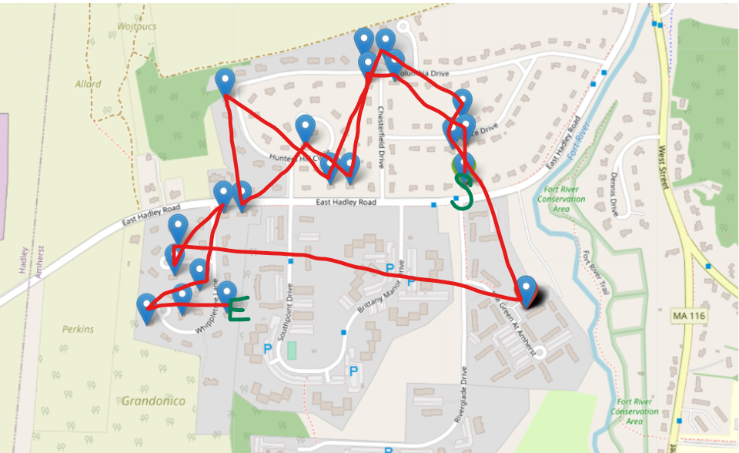

**Truck and drone route Cluster 1**

***Appendix C:***

**Truck-only route Cluster 2**

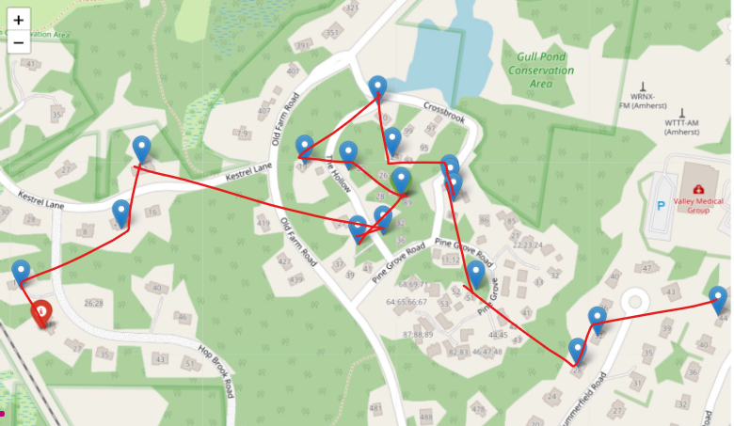

**Truck and drone route Cluster 2**

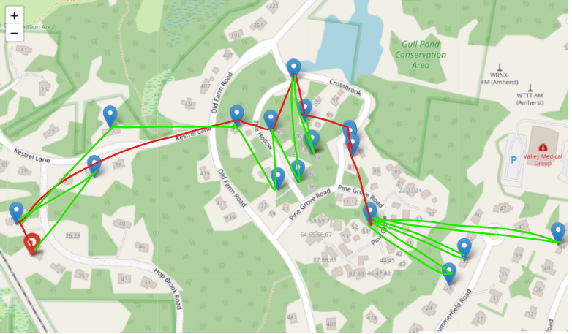

***Appendix D:***

Data, C. (2019). *Hampshire County, Massachusetts (MA)*. Hampshire County, Massachusetts detailed profile - houses, real estate, cost of living, wages, work, agriculture, ancestries, and more. Retrieved April 12, 2023, from https://www.city-data.com/county/Hampshire_County-MA.html

***Appendix E:***

**2010**

Northeast Public Radio | By Jim Levulis, W. A. M. C. (2015, July 23). *Seen as Urban State, Massachusetts creates rural policy commission*. WAMC. Retrieved April 12, 2023, from https://www.wamc.org/new-england-news/2015-07-23/seen-as-urban-state-massachusetts-creates-rural-policy-commission

**2020**

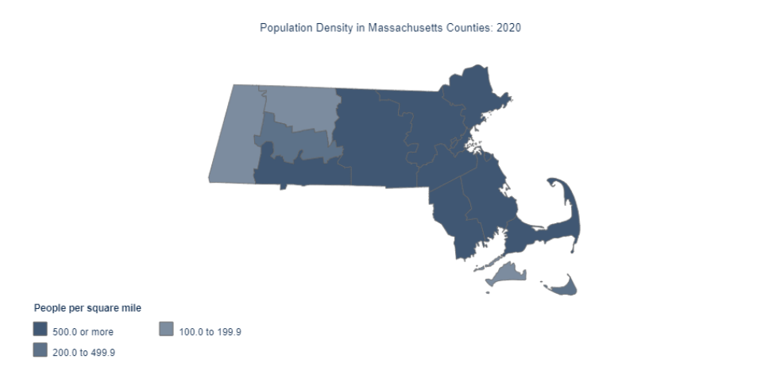

Staff, A. C. (2022, February 11). *Massachusetts population grew 7.4% to over 7 million from 2010 to 2020*. Census.gov. Retrieved April 12, 2023, from https://www.census.gov/library/stories/state-by-state/massachusetts-population-change-between-census-decade.html

***Appendix F:***

America, A. (2022). *Free Hampshire County, Massachusetts Topo Maps & Elevations*. AnyplaceAmerica. Retrieved April 12, 2023, from https://www.anyplaceamerica.com/directory/ma/hampshire-county-25015/